**Wi-Fi Controlled Office Automation**

Our project is a fairly simple attempt to achieve the goal of office automation. In a broader sense, the whole point of technology is to make our lives simpler by engineering it in ways which suits us.

In this project, the main input will be given by us in the form of a speech signal or through the app. In order to process this speech signal which is primarily mechanical i.e. sound, we have developed an application. This application converts the mechanical sound waves into electrically processible signals. It will be converted to a text format which is then sent to the raspberry pi using a Wi-Fi module. The raspberry pi acts as the bridge between the signal processing side and the physical output generation i.e. controlling the working of lights and fans. Then finally a relay module is used to control the outputs from the lights and fans. We are also displaying the temperature and humidity of the room in the app using the DHT sensor.

**BLOCK DIAGRAM:**

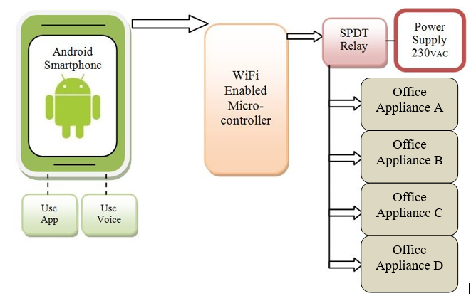

**WORKING:**

In the mentioned project we have made use of a relay module as a switch to control the functioning of the electrical appliances. We are giving input as voice command or from the app(Users choice) to a self-designed mobile application which then converts(voice input) to text form and transmits it to the Firebase via a Wifi module that serves as the connection between our mobile application and our micro-processor Raspberry pi. This signal received by the raspberry pi serves as its input for which it gives a certain output according to the code we have provided. Our relay module draws power from the raspberry pi directly and its working is based on the code provided to it.

Suppose if the user gives a certain voice command “Lights On” on the mobile application, it will be converted to text form and transmitted to the firebase via the wifi module. This output of the application thus send will act as the input for raspberry pi and it will process the signal and send a command to the circuit through the relay module and the lights will be switched on.

Similarly, it will work in the same way for other commands like “Lights off”, “Fan on”, “Fan off” etcetera. For every command given by the user, our application will process it, it will go through its algorithm and try to find the suitable output for the same, but if none of the inputs matches then our application will display the output as “Invalid command”.

**Circuit Diagram**

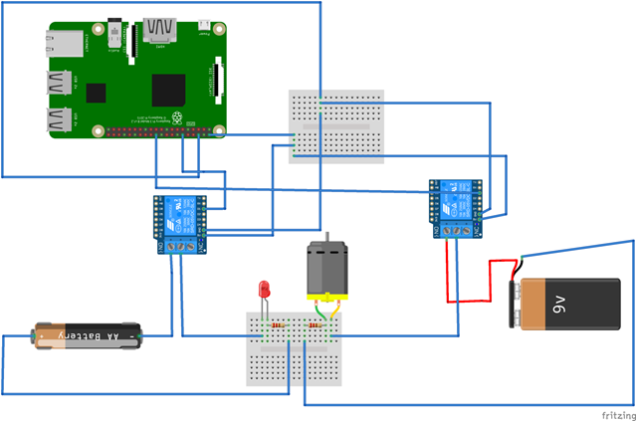

**HARDWARE CIRCUIT:**

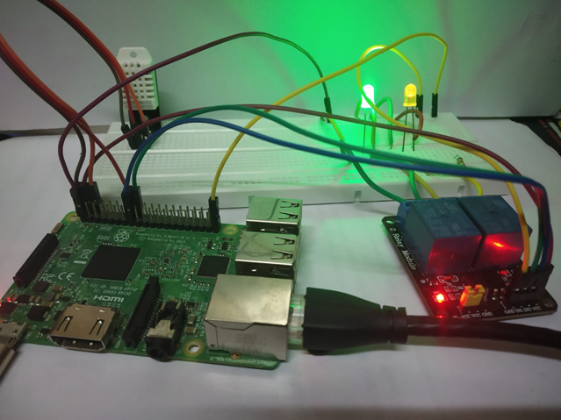

**Mobile Application**

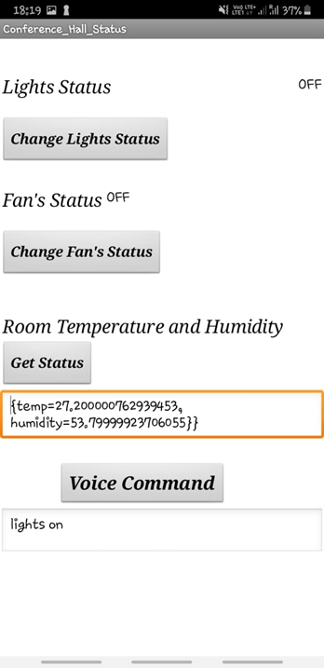

**Firebase:**

